Mujtaba shahid faizi
bscs-5a
#131818
lab 11 of OS

Task1:
Code:

#include<stdio.h>
#define max 25

void main()
{
int frame[10];
int i,j,k,nf,np=0,page[max],temp;
int flag=0,pf=0,top=0,hits=0;
printf("Enter no. of Frames:");
scanf("%d",&nf);
for(i=0;i<nf;i++)
frame[i]=-1;
printf("Enter pages (press -999 to exit):\n");
for(i=0;i<max;i++)
{
scanf("%d",&temp);
if(temp==-999) break; //to end page references
page[i]=temp;
np++;
}
for(i=0;i<np;i++)
{
flag=0;
for(j=0;j<nf;j++)
{
if(frame[j]==page[i]) //if page already in execution i.e. page hit
{
hits++;
printf("\n\t");
flag=1;break;
}
}
if(flag==0) //i.e. page fault
{
frame[top]=page[i]; //replacing page based on FIFO
top++;
printf("\nFault: ");
pf++;
if(top>=nf) //top getting greater than frames
top=0;
}
for(k=0;k<nf;k++)
printf("%d\t",frame[k]);
}
printf("\nNumber of page faults is: %d ",pf);

printf("\nNumber of page hits is: %d ",hits);
}

Screenshots:

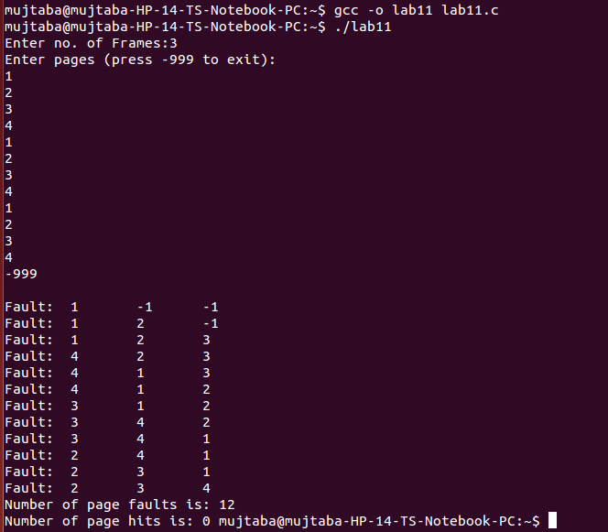

Task2:
Code:

#include<stdio.h>
int main()
{
int i,j=0,n,a[50],frame[10],no,k,avail,count=0,hits=0;
printf("\n ENTER THE NUMBER OF PAGES:\n");
scanf("%d",&n);
printf("\n ENTER THE PAGE NUMBER :\n");
for(i=1;i<=n;i++)
scanf("%d",&a[i]);
printf("\n ENTER THE NUMBER OF FRAMES :");
scanf("%d",&no);

for(i=0;i<no;i++){
frame[i]= -1; } //-1 means no page allocation

printf("\t\tFrame1\tFrame2\tFrame3\n");
for(i=1;i<=n;i++)
{
printf("%d\t\t",a[i]);
avail=0;
for(k=0;k<no;k++)
if(frame[k]==a[i]){ //if page is already in execution in any frame
avail=1;
hits++;
for(k=0;k<no;k++)
printf("%d\t",frame[k]); //page executing in each frame
}
if (avail==0)
{
frame[j]=a[i]; //assign a new page in execution
j=(j+1)%no; //based on LRU(i.e. when j reaches 3, value goes back to 0) to replace the page in the jth frame
count++; //page fault
for(k=0;k<no;k++)
printf("%d\t",frame[k]); //page executing in each frame
}
printf("\n");
}
printf("Page Fault Is %d\n",count);
printf("Page Hits Is %d\n",hits);
return 0;
}

Screenshots:
